Filitalia International & Foundation
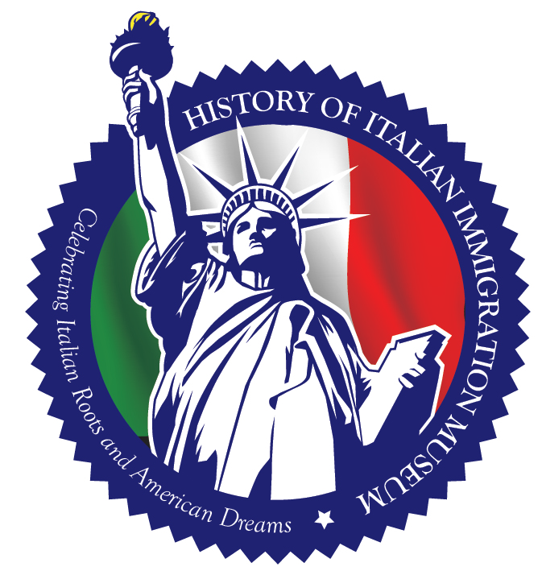
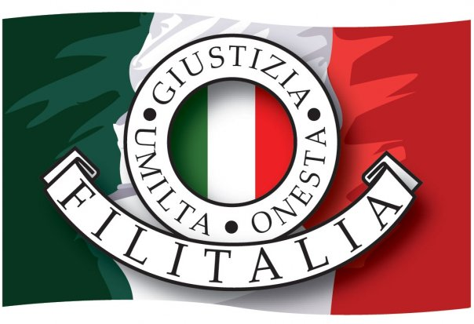
CAPITAL CAMPAIGN
BUY A TILE AND HELP SUPPORT
HISTORY OF ITALIAN IMMIGRATION MUSEUM

ADMISSION
Filitalia and HIIM Members = Free
Non-Members = $5.00
Children (12 & under) = $3.00

MUSEUM HOURS
Wednesday 1:30pm-5:30pm
Friday 3:00 PM to 8:00 PM
(Hours subject to change)
*Private tours upon request*

PERSONALIZED “REMEMBERING YOUR LOVED ONE”S” TILES MAKE GREAT GIFTS. YOU CAN GIVE A GIFT THAT WILL LAST YEARS IN THE NAME OF YOUR SPOUSE, FAMILY MEMBER, OR YOURSELF. EVEN HAVE YOUR COMPANY SPONSOR A TILE AND SHOW YOUR SUPPORT FOR THE PRESERVATION OF ITALIAN AND IMMIGRANT CULTURE IN PHILADELPHIA. SPONSOR A TILE TO HONOR YOUR CULTURE AND HAVE THE ENGRAVED NAME FOREVER DISPLAYED ON THE SIDEWALK OF SOUTH PHILADELPHIA.
All engraving is limited to up to 50 characters per paver.
See back for Rendering. Each tile is “12 x12”

HISTORY OF THE MUSEUM
The official opening of the History of the Italian Immigration Museum is a history making event. It has been a community accomplishment that enables to keep the memory alive for all the efforts made by past generations.
It all started from a vision that our Founder, Dr. Pasquale Nestico had two years ago, June 2012. In the history of our organization, Dr. Nestico has had many dreams and vision and I am happy to say that they became a reality. We have this beautiful culture center where we have Italian lessons, cooking lessons, culture events and now the Museum.
I have learned that all his possible when you have strong leaders, like our Founder, Dr. Nestico with vision, commitment, passion, integrity and strong determination but a leader needs also his people and I am happy to say that we have loyal members that support us in our projects. Thank you to our members, BOD and all of you that came out here today to celebrate with us this historical event.
It is in this spirit that I take this opportunity to thank the Co-chair of the Museum, Michael Bonasera for his hard work and passion he has demonstrated and Wanda Bonasera, Project Manager.
In addition I would like to thank Paula DeSantis Bonavitacola, chair person of the fund raining committee. The 1st fund raising event at the Pyramid Club was a huge success.
Our mission is language and culture and service to others and our motto is Humility, Justice and Honesty.

Rosetta Miriello, President Filitalia International

______(Row 1) $5,000.00
______(Row 2) $4,500.00
______(Row 3) $4,000.00
______(Row 4) $3,000.00

______(Row 5) $2,500.00
______(Row 6) $2,500.00
______(Row 7) $1,000.00
______(Row 8) $1,000.00
______(Row 9) $500.00
______(Row 10) $500.00
______(Row 11) $250.00

Tile #________
Purchased By:
Name:______________________________________
Adress:______________________________________
City:______________State:_____zip:______________
Telephone No.________________________________
Email________________________________________

www.filitaliainternational.com
Filitalia Foundation 501(c)3 is a private non-profit organization created in 1987 and The History of Italian Immigration Museum exists to preserve the tangible and intangible heritage of Italian Americans through stories that
permeate all cultures. HIIM connects the Italian-American community with its cultural roots and shares that heritage with people of all backgrounds by engaging visitors in participatory and educational programming.

--------------------------------------------------------------------------------------------------------------------------------------------------------------------
Engraving: PLEASE PRINT LEGIBLY/ ALL ENGRAVING SUBJECT TO COMMITTEE APPROVAL
Limited to up to 50 characters per paver. Please include, Family Name, Year of Arrival and City(or Province) of Origin.

Please return completed form along with check payable to:
CONTACT:
Caitlin Borrelli, executive assistant Filitalia.borrelli@gmail.com
215.334.882 www.filitaliainternational.com
Filitalia International
1809 W. Oregon Ave, Philadelphia PA 19145

